Directions: This is a closed-book, closed-note test with one and 1/2 hours allotted. Some questions are more difficult than others so allocate your time wisely. If any question is ambiguous, state your assumptions and answer the question based on your assumptions. You do not have to turn in this document.

- (20 points) Process Definition: A process is a “program in execution.”
- Describe the salient features or characteristics associated with a process that differentiates it from a program.
- Enumerate and explain (briefly) all the operations that can be performed on processes.

- (20 points) Modeling Processes
- Draw the Process State Diagram, labeling all edges and states.
- Enumerate which of the edges are related to scheduling events and why. (Recall that this question may have several answers, hence the “why” is the important part of the question.)
- When the Operating Environment performs a context switch, what information needs to be saved for later use, where is this information stored?

- (25 points) Job Scheduling: Three jobs, A, B, and C, arrive in the system at the same time – at time zero. Each process has different CPU- and IO-burst; these times are 3-3, 5-1, and 1-5, respectively. In the following execution profile, which uses a scheduling methodology that gives priority to the job that has spent the longest time in the ready queue, answer the following questions:
  - What is the average turnaround time for the system?
  - Is this system a preemptive system? If it is preemptive, which is its time quantum?
  - Enumerate the type of event/s that occurs at the following times:
0, 6, 15, 28

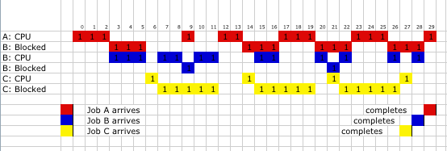

- (20 points) Thread Models: One of the benefits provided by threads is responsiveness. As stated by our textbook, “Multithreading … may allow a program to continue running even if part of it is blocked or is performing a lengthy operation, thereby increasing responsiveness to the user.” Our textbook also describes three multithreading models.
- Enumerate and describe these three models.
- Which of the three models does not allow a program continue running if one of its threads blocks? Explain your answer.

- (15 points) Interprocess Communication: From a general perspective, explain what a pipe is and some of its possible characteristics (naming, synchronization, and buffering.)

- (5 points) Define what a zombie process is. What information is associated with such a process, and why do we have such a process?

This question is not specific to Unix Pipe that you used in the laboratory assignment, but rather to the general concept of a pipe.

